Holy Eucharist Rite II: The Ministry of the Word

Prelude Music
Processional Hymn #337……. “And Now, O Father, Mindful of Thy Love”
The service is followed in the Book of Common Prayer, page numbers are indicated below
Opening Sentence………………………………………p. 355
Gloria in Excelsis: “Glory to God”………………….… S280
Opening Collect………………………….……. bulletin insert
Welcome, children!
At this time, the children proceed to the Hall with Sunday School teachers for Sunday School, and will return at the passing of the Peace.
Old Testament Reading…………………..……. bulletin insert
Psalm…………………………………………..bulletin insert
New Testament Reading……………….… …… bulletin insert

Celtic Alleluia (Sung before and after the Gospel is read)
Gospel ……….. (All stand)…..…………….…. bulletin insert

Sermon:……………………....……...........Rev. Mary Trainor

Nicene Creed…………………………………… .. …p. 358

Prayers of the People…………………. ….. p. 387(Form III)

Those in need of our prayers: For healing: Bernie, Dan, Adeline, Bruce, Pam, Connie, Frances, Tony; Aaron, Ken, and all those deployed.
Repose of the soul of Chad.
Diocesan Cycle of Prayer: St. John’s, Wausau

Prayer of Thanksgiving for our new Diocese of Fond du Lac bishop, elected yesterday: ”O God, by your grace you have called us in this Diocese to a goodly fellowship of faith. Bless our new Bishop-elect, other clergy, and all our people. Grant that your Word may be truly preached and truly heard, your Sacraments faithfully administered and faithfully received. By your Spirit, fashion our lives according to the example of your Son, and grant that we may show the power of your love to all among whom we live; through Jesus Christ our Lord. Amen.

Confession …………….….....................................p. 360
Priest pronounces absolution of sins

The Peace - please greet each other in the name of Christ

Offertory Hymn - Supplementary Hymnal #8………“Sweet Hour of Prayer”

Today is “Commitment Sunday,”
when we hand in our pledge cards for the coming year, offering to God our time, talent, and treasure through our participation at St. John’s.
[Pledges can be changed at any time; they are important because they enable the Bishop’s Committee to plan ministry for the coming year. Any level or amount of pledge is welcome! Other than God, the only person who knows about your pledge is the treasurer.]

"Praise God from whom all blessings flow"...Hymnal #380 v 3

The Great Thanksgiving
Eucharistic Prayer…Form A………………………….p. 361
Sanctus -“Holy, Holy, Holy”……. …………Hymnal # S130

All baptized Christians are invited to receive Holy Communion.

Post Communion Hymn #711… “See Ye First The Kingdom of God”
Concluding Prayer: ……………..…..………………..p. 366

Blessing

Recessional Hymn . . Supplemental Hymnal 56…..“Because He Lives”
Dismissal, Announcements and Postlude
+++++++++++++++++++++++++++++++++++++++++++
Today – following the service is a potluck lunch in celebration of our life together as a congregation which “Invites, Involves, Instructs, Inspires in Christ.” Enjoy the fellowship and food. Everyone is welcome!

If you are visiting for the first time today, welcome! Please see the pews for a special welcome card and information on St. John's. If you have questions about St. John’s or the Episcopal Church, Pastor Mary is happy to answer after the service.

This Week at St. John's:
Wed, Oct. 23 : 11 AM or 6:30 PM, The Wednesday Discussion Group, in Hall on Luke - after 11 AM group
Holy Eucharist (30 minutes). Pastor Mary is available for appointments.

St. John's Upcoming Events:
Nov. 3: All Saints Sunday
Nov. 3: 11 AM Bishop's Committee Meeting
Nov. 27, 7 PM, Shawano Ecumenical Thanksgiving Service, Sacred Heart Parish

Announcements

On Sunday, Nov. 3, we observe All Saints Sunday. On this day, we will remember in prayer those loved ones who have gone before. Please place, on the sign-up sheet in the Hall, names of those who you wish to be remembered during our time of prayer in the Sunday service.

Please bring non-perishable (canned or dried goods) foods to church and place them in the basket near the Church entrance; food is delivered weekly to the Shawano Food Pantry (check dates on food please). You can also bring cleaning supplies and toiletry items for those staying at the Shawano Domestic Abuse Shelter; please place these items in marked bins.

PICK UP IN THE RACK IN THE HALL:
- flyers that tell you about St. John's
- printed copy of the Church and Diocese electronic newsletter
- tracts that help with life's issues
- today’s sermon (copy)

St John’s staff:
Vicar- The Rev. Mary S. Trainor; Organist – Ted Myers
Bishop’s Committee: Senior Warden - Ron Stezenski; Jr. Warden- Art Frieberg; Marlene Brown, Nancy Clasen, Joe Keberlein, Wendy Hafner, LouAnne Zander; Treasurer - Sue Sazama; Clerk – Lois Renner; Youth Liaison, Ted Myers.
The Twenty-Second Sunday after Pentecost
October 20, 2013

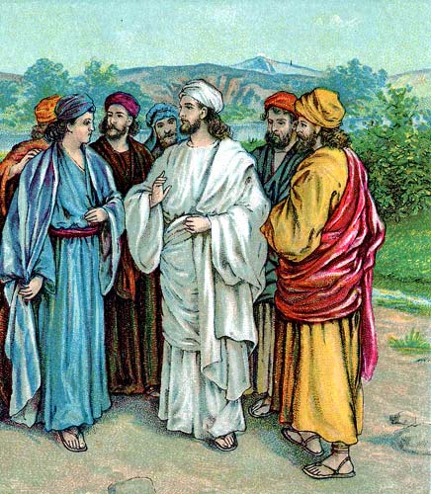
“Pray always and do not lose heart?”

St. John’s Episcopal Church

141 South Smalley St., Shawano, WI

http://www.shawanoepiscopal.org

The Rt. Rev. Russell Jacobus, Bishop

The Rev. Mary S. Trainor, Vicar

Church Phone 715-526-3686

Vicar’s Phone 715-252-4816

pastormaryt@gmail.com
www.marytrainorblogspot.com

